[1]

**System of Networked Sensors for Detection and Characterization of Underground Activity Design Validation Report**

First A. Author, *Fellow, IEEE*, Second B. Author, and Third C. Author, Jr., Member, IEEE

*Abstract*—The abstract must be a concise yet comprehensive reflection of what is in your article. In particular, the abstract must be self-contained, without abbreviations, footnotes, or references. It should be a microcosm of the full article. The abstract must be between 150–250 words. Be sure that you adhere to these limits; otherwise, you will need to edit your abstract accordingly. The abstract must be written as one paragraph and should not contain displayed mathematical equations or tabular material. The abstract should include three or four different keywords or phrases, as this will help readers to find it. It is important to avoid over-repetition of such phrases as this can result in a page being rejected by search engines. Ensure that your abstract reads well and is grammatically correct.

*Index Terms*—Enter key words or phrases in alphabetical order, separated by commas. For a list of suggested keywords, send a blank e-mail to [keywords@ieee.org](mailto:keywords@ieee.org) or visit <http://www.ieee.org/organizations/pubs/ani_prod/keywrd98.txt>

# Problem Definition

## Motivations

For our senior design project, we are tasked with designing a system of networked sensors for detection and characterization of unauthorized underground activity. The main purpose of this wireless sensor array is to provide security for government property i.e; military bases, government facilities, military bases at home/abroad, and national border security. The detection of unauthorized underground activity is costly, complex, time consuming to set up, calibrate, and maintain, often difficult to interpret, and can output ambiguous information. Hence, there presents a need for a cheaper and more accurate sensor array that can categorize, detect, and transmit these different types of underground activity.

## Customer Requirements

We received this research topic from the Capstone Marketplace through our Customer Mentor at the Stevens Institute for technology. Since this research topic comes from a government contract, the main purpose of this project is to provide security for government property. The Capstone Marketplace prompt for this project provided a list of features that our customer would like the system to have. These system requirements include that the security system must be:

* Portable, durable, and unobtrusive
* Easy to set up and take down
* Able to cover a 100 meter radius
* Cheap
* Wireless Network of sensors (at least 2)
* Self-contained power source
* Able to process data and categorize types of signals
  + i.e. determine the likelihood of whether a signal received was from a passing truck or from a tunnel being dug.
* Able to send processed signal data to a laptop for user to interpret data

Over time and through many meetings among the team members, we have come to the conclusion that the project will be able to meet some of these requirements, but not all. We plan to leave this project (as well as all our research and work) available to future engineering students so they can continue this project with the hopes of improving it where we could not.

## Engineering Requirements

Describe the engineering/ class requirements for this project

# System Diagram

## Sub-systems and Interconnections

Overview of section

### *Flow Chart Diagrams*

### Flow chart image and caption

### *Computer Graphics*

### Graphics and caption

# Team Dynamics

## Team Roles

Overview of Section

### *Augustus Standeven*

### Augustus helped with many different sections of the project. As one of the seniors in the project, he helped conduct the initial research for the project and he also helped create the initial design. Augustus worked extensively on vibration data acquisition, system design/ implementation, data capture, and Python coding. For the Python coding, he specifically helped create and implement the data acquisition code, the machine learning algorithm, and the master script.

### *Tyler McKean*

### Tyler assisted in several sections of the project as a senior student team member of the project. He participated in the initial researching and designing into the area of underground vibration detection. In terms of hardware, Tyler lead the team in the data capturing of vibration signals using the Arduino subsystem and designing a DC Offset PCB required to fully capture oscillation data from the ground vibrations. For software, Tyler primarily wrote the preprocessing and feature extraction algorithms in MATLAB that later were converted to Python scripts, which would run on our Raspberry Pi subsystem.

### *Vulindsky Fanfan*

### Detailed description of all roles team member participated in.

### *Yohannes Kidane*

### Detailed description of all roles team member participated in.

## Team Communication

weekly communications, document sharing, and project management: MS Project Management

# Components and Final Budget

## Components

Describe the components used in our project.

## Final Budget

Describe the final budget for our project.

# Design Improvements

Describe the design improvements over time

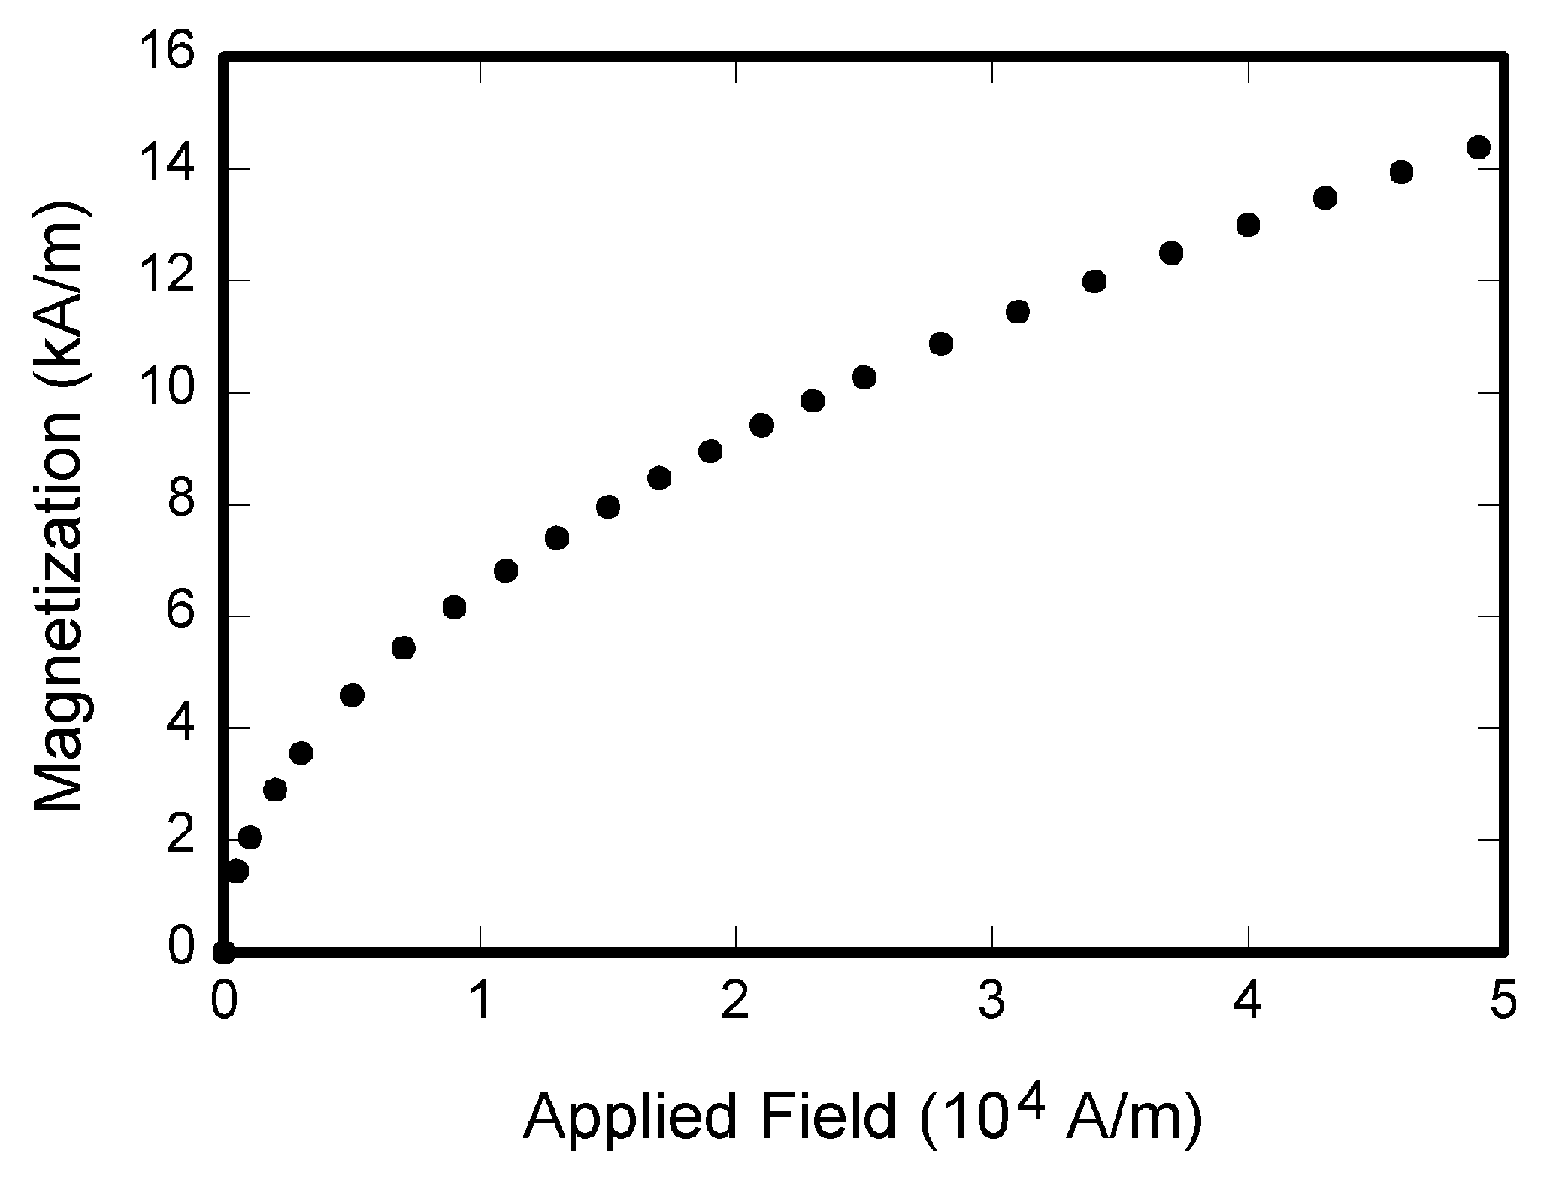

Fig. 1. Magnetization as a function of applied field. Note that “Fig.” is abbreviated. There is a period after the figure number, followed by two spaces. It is good practice to explain the significance of the figure in the caption.

TABLE I

Units for Magnetic Properties

|  |  |  |
| --- | --- | --- |
| Symbol | Quantity | Conversion from Gaussian and  CGS EMU to SI a |
| Φ | magnetic flux | 1 Mx → 10−8 Wb = 10−8 V·s |
| *B* | magnetic flux density,  magnetic induction | 1 G → 10−4 T = 10−4 Wb/m2 |
| *H* | magnetic field strength | 1 Oe → 103/(4π) A/m |
| *m* | magnetic moment | 1 erg/G = 1 emu  → 10−3 A·m2 = 10−3 J/T |
| *M* | magnetization | 1 erg/(G·cm3) = 1 emu/cm3  → 103 A/m |
| 4π*M* | magnetization | 1 G → 103/(4π) A/m |
| σ | specific magnetization | 1 erg/(G·g) = 1 emu/g → 1 A·m2/kg |
| *j* | magnetic dipole  moment | 1 erg/G = 1 emu  → 4π × 10−10 Wb·m |
| *J* | magnetic polarization | 1 erg/(G·cm3) = 1 emu/cm3  → 4π × 10−4 T |
| χ*,* κ | susceptibility | 1 → 4π |
| χρ | mass susceptibility | 1 cm3/g → 4π × 10−3 m3/kg |
| μ | permeability | 1 → 4π × 10−7 H/m  = 4π × 10−7 Wb/(A·m) |
| μr | relative permeability | μ → μr |
| *w, W* | energy density | 1 erg/cm3 → 10−1 J/m3 |
| *N, D* | demagnetizing factor | 1 → 1/(4π) |

Vertical lines are optional in tables. Statements that serve as captions for the entire table do not need footnote letters.

aGaussian units are the same as cg emu for magnetostatics; Mx = maxwell, G = gauss, Oe = oersted; Wb = weber, V = volt, s = second, T = tesla, m = meter, A = ampere, J = joule, kg = kilogram, H = henry.

# Ethical Considerations

Describe the various ethical considerations we took throughout this project.

# PCB

## Purpose

Purpose of PCB

## Design

Design of PCB

## Performance

Performance of PCB

# Design Validation

## Validation Test 1

Overview of validation test 1

## Validation Test 2

Overview of validation test 2

## Validation Test 3

Overview of validation test 3

# Validation Data

## Validation Test 1

Data/ results from validation test 1

## Validation Test 2

Data/ results from validation test 2

## Validation Test 3

Data/ results from validation test 3

# Deliverables

Overview of final deliverables

# future Work

Overview of future work for the project (for our team as well as future teams.

References

*Basic format for books:*

J. K. Author, “Title of chapter in the book,” in *Title of His Published Book, x*th ed. City of Publisher, (only U.S. State), Country: Abbrev. of Publisher, year, ch. *x*, sec. *x*, pp. *xxx–xxx.*

*Examples:*

1. G. O. Young, “Synthetic structure of industrial plastics,” in *Plastics,* 2nd ed., vol. 3, J. Peters, Ed. New York, NY, USA: McGraw-Hill, 1964, pp. 15–64.
2. W.-K. Chen, *Linear Networks and Systems.* Belmont, CA, USA: Wadsworth, 1993, pp. 123–135.

*Basic format for periodicals:*

J. K. Author, “Name of paper,” *Abbrev. Title of Periodical*, vol. *x, no*. *x,* pp*. xxx-xxx,* Abbrev. Month, year, DOI. 10.1109.*XXX*.123456.

*Examples:*

1. J. U. Duncombe, “Infrared navigation—Part I: An assessment of feasibility,” *IEEE Trans. Electron Devices*, vol. ED-11, no. 1, pp. 34–39, Jan. 1959, 10.1109/TED.2016.2628402.
2. E. P. Wigner, “Theory of traveling-wave optical laser,”   
   *Phys. Rev*.,   
   vol. 134, pp. A635–A646, Dec. 1965.
3. E. H. Miller, “A note on reflector arrays,” *IEEE Trans. Antennas Propagat*., to be published.

*Basic format for reports:*

J. K. Author, “Title of report,” Abbrev. Name of Co., City of Co., Abbrev. State, Country, Rep. *xxx*, year.

*Examples:*

1. E. E. Reber, R. L. Michell, and C. J. Carter, “Oxygen absorption in the earth’s atmosphere,” Aerospace Corp., Los Angeles, CA, USA, Tech. Rep. TR-0200 (4230-46)-3, Nov. 1988.
2. J. H. Davis and J. R. Cogdell, “Calibration program for the 16-foot antenna,” Elect. Eng. Res. Lab., Univ. Texas, Austin, TX, USA, Tech. Memo. NGL-006-69-3, Nov. 15, 1987.

*Basic format for handbooks:*

*Name of Manual/Handbook, x* ed., Abbrev. Name of Co., City of Co., Abbrev. State, Country, year, pp. *xxx-xxx.*

*Examples:*

1. *Transmission Systems for Communications*, 3rd ed., Western Electric Co., Winston-Salem, NC, USA, 1985, pp. 44–60.
2. *Motorola Semiconductor Data Manual*, Motorola Semiconductor Products Inc., Phoenix, AZ, USA, 1989.

*Basic format for books (when available online):*

J. K. Author, “Title of chapter in the book,” in *Title of Published Book*, *x*th ed. City of Publisher, State, Country: Abbrev. of Publisher, year, ch. *x*, sec. *x*, pp. *xxx–xxx*. [Online]. Available: http://www.web.com

*Examples:*

1. G. O. Young, “Synthetic structure of industrial plastics,” in Plastics, vol. 3, Polymers of Hexadromicon, J. Peters, Ed., 2nd ed. New York, NY, USA: McGraw-Hill, 1964, pp. 15-64. [Online]. Available: http://www.bookref.com.
2. *The Founders’ Constitution*, Philip B. Kurland and Ralph Lerner, eds., Chicago, IL, USA: Univ. Chicago Press, 1987. [Online]. Available: http://press-pubs.uchicago.edu/founders/
3. The Terahertz Wave eBook. ZOmega Terahertz Corp., 2014. [Online]. Available: http://dl.z-thz.com/eBook/zomega_ebook_pdf_1206_sr.pdf. Accessed on: May 19, 2014.
4. Philip B. Kurland and Ralph Lerner, eds., *The Founders’ Constitution.* Chicago, IL, USA: Univ. of Chicago Press, 1987, Accessed on: Feb. 28, 2010, [Online] Available: http://press-pubs.uchicago.edu/founders/

*Basic format for journals (when available online):*

J. K. Author, “Name of paper,” *Abbrev. Title of Periodical*, vol. *x*, no. *x*, pp. *xxx-xxx*, Abbrev. Month, year. Accessed on: Month, Day, year, DOI: 10.1109.*XXX*.123456, [Online].

*Examples:*

1. J. S. Turner, “New directions in communications,” *IEEE J. Sel. Areas Commun*., vol. 13, no. 1, pp. 11-23, Jan. 1995.
2. W. P. Risk, G. S. Kino, and H. J. Shaw, “Fiber-optic frequency shifter using a surface acoustic wave incident at an oblique angle,” *Opt. Lett.*, vol. 11, no. 2, pp. 115–117, Feb. 1986.
3. P. Kopyt *et al., “*Electric properties of graphene-based conductive layers from DC up to terahertz range,” *IEEE THz Sci. Technol.,* to be published. DOI: 10.1109/TTHZ.2016.2544142.

*Basic format for papers presented at conferences (when available online):*

J.K. Author. (year, month). Title. presented at abbrev. conference title. [Type of Medium]. Available: site/path/file

*Example:*

1. PROCESS Corporation, Boston, MA, USA. Intranets: Internet technologies deployed behind the firewall for corporate productivity. Presented at INET96 Annual Meeting. [Online]. Available: http://home.process.com/Intranets/wp2.htp

*Basic format for reports and handbooks (when available online):*

J. K. Author. “Title of report,” Company. City, State, Country. Rep. no., (optional: vol./issue), Date. [Online] Available: site/path/file

*Examples:*

1. R. J. Hijmans and J. van Etten, “Raster: Geographic analysis and modeling with raster data,” R Package Version 2.0-12, Jan. 12, 2012. [Online]. Available: http://CRAN.R-project.org/package=raster
2. Teralyzer. Lytera UG, Kirchhain, Germany [Online]. Available: http://www.lytera.de/Terahertz_THz_Spectroscopy.php?id=home, Accessed on: Jun. 5, 2014

*Basic format for computer programs and electronic documents (when available online):*

Legislative body. Number of Congress, Session. (year, month day). *Number of bill or resolution*, *Title*. [Type of medium]. Available: site/path/file

***NOTE:*** ISO recommends that capitalization follow the accepted practice for the language or script in which the information is given.

*Example:*

1. U.S. House. 102nd Congress, 1st Session. (1991, Jan. 11). *H. Con. Res. 1, Sense of the Congress on Approval of Military Action*. [Online]. Available: LEXIS Library: GENFED File: BILLS

*Basic format for patents (when available online):*

Name of the invention, by inventor’s name. (year, month day). Patent Number[Type of medium]. Available: site/path/file

*Example:*

1. Musical toothbrush with mirror, by L.M.R. Brooks. (1992, May 19). Patent D 326 189

[Online]. Available: NEXIS Library: LEXPAT File: DES

*Basic format for conference proceedings (published):*

J. K. Author, “Title of paper,” in *Abbreviated Name of Conf.*, City of Conf., Abbrev. State (if given), Country, year, pp. *xxxxxx.*

*Example:*

1. D. B. Payne and J. R. Stern, “Wavelength-switched pas- sively coupled single-mode optical network,” in *Proc. IOOC-ECOC,* Boston, MA, USA,1985,   
   pp. 585–590.

*Example for papers presented at conferences (unpublished):*

1. D. Ebehard and E. Voges, “Digital single sideband detection for interferometric sensors,” presented at the *2nd Int. Conf. Optical Fiber Sensors,* Stuttgart, Germany, Jan. 2-5, 1984.

*Basic format for patents:*

J. K. Author, “Title of patent,” U.S. Patent *x xxx xxx*, Abbrev. Month, day, year.

*Example:*

1. G. Brandli and M. Dick, “Alternating current fed power supply,” U.S. Patent 4 084 217, Nov. 4, 1978.

*Basic format**for theses (M.S.) and dissertations (Ph.D.):*

a) J. K. Author, “Title of thesis,” M.S. thesis, Abbrev. Dept., Abbrev. Univ., City of Univ., Abbrev. State, year.

b) J. K. Author, “Title of dissertation,” Ph.D. dissertation, Abbrev. Dept., Abbrev. Univ., City of Univ., Abbrev. State, year.

*Examples:*

1. J. O. Williams, “Narrow-band analyzer,” Ph.D. dissertation, Dept. Elect. Eng., Harvard Univ., Cambridge, MA, USA, 1993.
2. N. Kawasaki, “Parametric study of thermal and chemical nonequilibrium nozzle flow,” M.S. thesis, Dept. Electron. Eng., Osaka Univ., Osaka, Japan, 1993.

*Basic format for the most common types of unpublished references:*

a) J. K. Author, private communication, Abbrev. Month, year.

b) J. K. Author, “Title of paper,” unpublished.

c) J. K. Author, “Title of paper,” to be published.

*Examples:*

1. A. Harrison, private communication, May 1995.
2. B. Smith, “An approach to graphs of linear forms,” unpublished.
3. A. Brahms, “Representation error for real numbers in binary computer arithmetic,” IEEE Computer Group Repository, Paper R-67-85.

*Basic formats for standards:*

a) *Title of Standard*, Standard number, date.

b) *Title of Standard*, Standard number, Corporate author, location, date.

*Examples:*

1. IEEE Criteria for Class IE Electric Systems, IEEE Standard 308, 1969.
2. Letter Symbols for Quantities, ANSI Standard Y10.5-1968.

*Article number in reference examples:*

1. R. Fardel, M. Nagel, F. Nuesch, T. Lippert, and A. Wokaun, “Fabrication of organic light emitting diode pixels by laser-assisted forward transfer,” *Appl. Phys. Lett.*, vol. 91, no. 6, Aug. 2007, Art. no. 061103.
2. J. Zhang and N. Tansu, “Optical gain and laser characteristics of InGaN quantum wells on ternary InGaN substrates,” *IEEE Photon. J.*, vol. 5, no. 2, Apr. 2013, Art. no. 2600111

*Example when using et al.:*

1. S. Azodolmolky *et al.*, Experimental demonstration of an impairment aware network planning and operation tool for transparent/translucent optical networks,” *J. Lightw. Technol.*, vol. 29, no. 4, pp. 439–448, Sep. 2011.

**First A. Author** (M’76–SM’81–F’87) and all authors may include biographies. Biographies are often not included in conference-related papers. This author became a Member (M) of IEEE in 1976, a Senior Member (SM) in 1981, and a Fellow (F) in 1987. The first paragraph may contain a place and/or date of birth (list place, then date). Next, the author’s educational background is listed. The degrees should be listed with type of degree in what field, which institution, city, state, and country, and year the degree was earned. The author’s major field of study should be lower-cased.

The second paragraph uses the pronoun of the person (he or she) and not the author’s last name. It lists military and work experience, including summer and fellowship jobs. Job titles are capitalized. The current job must have a location; previous positions may be listed without one. Information concerning previous publications may be included. Try not to list more than three books or published articles. The format for listing publishers of a book within the biography is: title of book (publisher name, year) similar to a reference. Current and previous research interests end the paragraph.

The third paragraph begins with the author’s title and last name (e.g., Dr. Smith, Prof. Jones, Mr. Kajor, Ms. Hunter). List any memberships in professional societies other than the IEEE. Finally, list any awards and work for IEEE committees and publications. If a photograph is provided, it should be of good quality, and professional-looking. Following are two examples of an author’s biography.

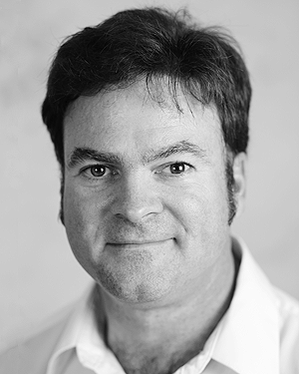**Second B. Author** was born in Greenwich Village, New York, NY, USA in 1977. He received the B.S. and M.S. degrees in aerospace engineering from the University of Virginia, Charlottesville, in 2001 and the Ph.D. degree in mechanical engineering from Drexel University, Philadelphia, PA, in 2008.

From 2001 to 2004, he was a Research Assistant with the Princeton Plasma Physics Laboratory. Since 2009, he has been an Assistant Professor with the Mechanical Engineering Department, Texas A&M University, College Station. He is the author of three books, more than 150 articles, and more than 70 inventions. His research interests include high-pressure and high-density nonthermal plasma discharge processes and applications, microscale plasma discharges, discharges in liquids, spectroscopic diagnostics, plasma propulsion, and innovation plasma applications. He is an Associate Editor of the journal *Earth*, *Moon*, *Planets*, and holds two patents.

Dr. Author was a recipient of the International Association of Geomagnetism and Aeronomy Young Scientist Award for Excellence in 2008, and the IEEE Electromagnetic Compatibility Society Best Symposium Paper Award in 2011.

**Third C. Author, Jr.** (M’87) received the B.S. degree in mechanical engineering from National Chung Cheng University, Chiayi, Taiwan, in 2004 and the M.S. degree in mechanical engineering from National Tsing Hua University, Hsinchu, Taiwan, in 2006. He is currently pursuing the Ph.D. degree in mechanical engineering at Texas A&M University, College Station, TX, USA.

From 2008 to 2009, he was a Research Assistant with the Institute of Physics, Academia Sinica, Tapei, Taiwan. His research interest includes the development of surface processing and biological/medical treatment techniques using nonthermal atmospheric pressure plasmas, fundamental study of plasma sources, and fabrication of micro- or nanostructured surfaces.

Mr. Author’s awards and honors include the Frew Fellowship (Australian Academy of Science), the I. I. Rabi Prize (APS), the European Frequency and Time Forum Award, the Carl Zeiss Research Award, the William F. Meggers Award and the Adolph Lomb Medal (OSA).

1. .